Case 1
Maja the Shelter cat.
By Anita Sonderup – Denmark
September - November 2014
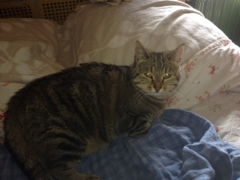
Case Description – 2 weeks with Maja
Maja is a one year old brown tabby female, who has been at a catshelter in Denmark from may 2014 until September 2014. She got neutered and vaccinated when she arrived at the shelter.
After the operation Maja got some problems around her wound. The stitches didn´t last and she had to be re-operated.
Since that incident no one could touch Maja around her stomach area and she got really aggressive if the staff tried to pick her up. Actually – she scared everyone away.
When I saw Maja the first time in august 2014, I wondered what was going on with her – I asked the staff about it, but didn´t really get a straight answer.
I went on my first T-touch clinic At Tilley Farm from 14-19 sept. 2014. When I got back the staff told me that Majas aggressiveness has gone worse – and that she would be put down two days later.
I didn´t think twice, and decided that Maja should have a chance, so I brought her to my home. The agreement with the shelter was that she either would be better or I should bring her back to the shelter.
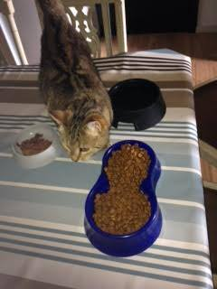 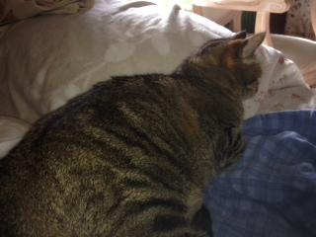
First photos of Maja in my home. As you can see on the Photos she is "out of shape" – She had a strange round shape around her stomach, which got me suspicious of roundworms.
Since it was my first work with t-touch and that I wanted to make a progress without trying I asked for help in my studygroup and got a lot of good advises.
On the first day I couldn´t touch her body directly, so I wrapped her in a blanket - just letting her head out - and did some light racoon touches around her ears and on top of her head and some raccoon-, lying- and clouded leopard touch on her body (on top of the blanket).
She actually relaxed a Little bit.
Later in the afternoon and in the evening I could touch her without the blanket. She even got real close to me on the bed and I could touch her all the way down her back.
The next morning she jumped away from me, as soon as I got in her room but immediatly returned to the bed. She purred loud - and rolled on her back, showing me her stomach - I didn´t touch it though.
Later that day I tried some careful wraps – just around her neck and some zig zags. She didn´t like me to touch her on the left side of her head - and her stomach was still an issue. I made a Labyrinth for her (on my husbands pooltable), but that was much too early for that.
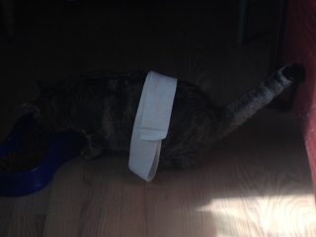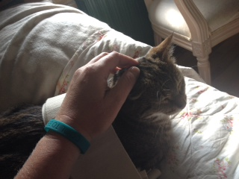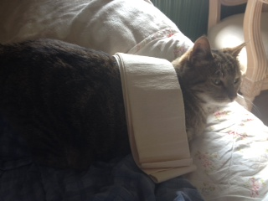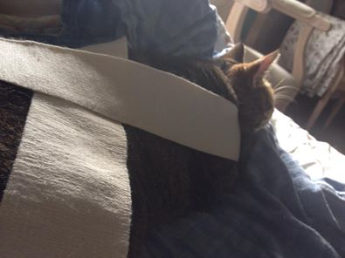
I went back to the shelter and talked to the vet again. She had seen Maya in the shelter, and didn´t found anything wrong with her besides the complication from the operation. I got the de-worming “kit” and gave that to Maya.
I continued to do racoon touches, clouded leopard touches and zig zags on her body – she got more and more relaxed around me and enjoyed the touches so much. I started to work on some belly lifts – she really liked that as well.
She is such a loving little cat, and before I knew it, she allowed me to touch her stomach for the first time. It was a great moment for the both of us. Around the same time her stomach wasn´t that round anymore, she increased her range of motion and I could see that she got the feeling in her body back. Now she could get her self clean on the back again and sit in different positions.
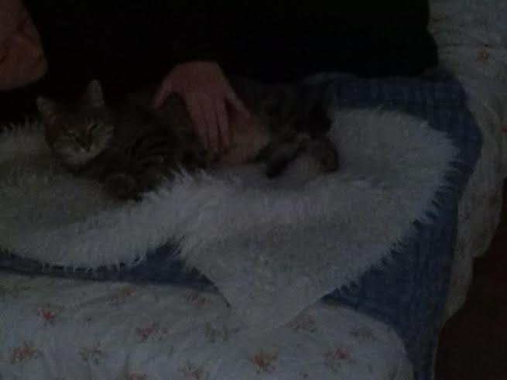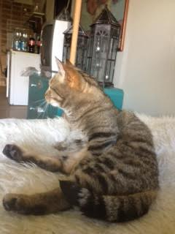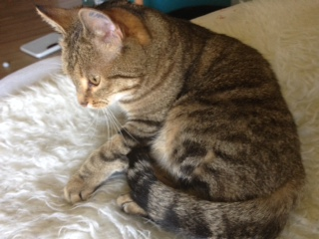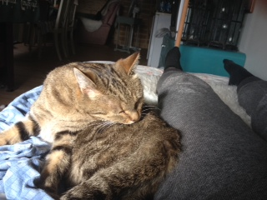
10 days after the first deworming, I gave her the second one – but there was no wormes. On the same time a friend of mine came to meet Maja – and she immediately fell in love with her, and decided that she would like to adopt her.
The day before we moved Maja, she did the Labyrinth on my husbands pool table on her own. I didn´t even encourage her to do it – she just did. I knew that I made the right decision with Maja – and that she was ready.
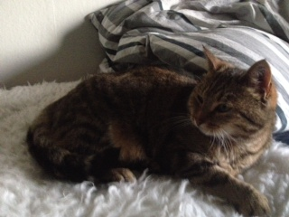 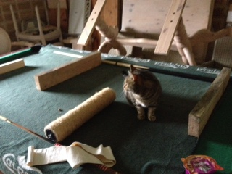

I still almost can´t believe how such a little work could change a cats life – but it did.
What I did was;
I moved her the from the shelter
I balanced her body with wraps and belly lifts
Made t- Touched on her.
Found her a home.
Maja Today
She loved the outdoor life at the shelter – she went in the yard and could lie there on the ground with her round stomach pointing out like a sore thumb. Now she is relaxed and is living at my friends house with her and her son.
I have seen Maja 1 time since she moved there and shown my friend raccoon touches, clouded leopard touches and the zig zags touches – they have now bonded even more through the t- touches. Maja is relaxed – she has been in and out the garden for some time now – but she really enjoys indoor live more. The best part of it is that she has caught 2 mice, which is so amazing and the first steps towards getting back to being a real cat again;)
